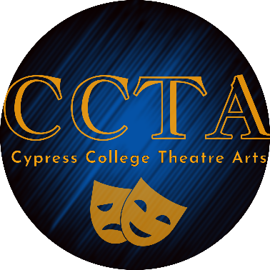
AUDITION CARD - Play
Show Auditioning For: Big Love
I will accept ANY role, including Ensemble 
I will ONLY accept the role(s) of

Please PRINT clearly
Name (as you wish it to appear on program) _____________________________
Pronouns (optional)
Phone # Work # Cell #
E-Mail:
Address: City: Zip:
Height:
Background information: Please answer the following yes or no
Do you have reliable transportation to and from rehearsal?
If so, what? (ie: parents, friend, car, bike, etc.)?
To participate in a production you must be a current Cypress College student. Are you…
A. A current student B. In the process of applying to be a student C. Neither
Please acknowledge that you understand that if cast in a show you must register for both a performance class AND a separate Stage Crew class, where you will have a behind-the-scenes assignment. Initial here

EMERGENCY CONTACT PERSON: ___________________________________ Relation: ____________

Home Phone#: ________________________ Cell Phone#: ______________________

Please list any disabilities, medical problems, allergies, or special accommodations needed:

Page 1 of 2

Class and Work Schedule: Please fill out your work and class schedule including class name and room number.
Be sure to include all outside commitments (church, shows, chorus, other schools, etc…)
 | Monday | Tuesday | Wednesday | Thursday | Friday | Saturday | Sunday
8-9:00am
9-10:00 am
10-11:00 am
11-12:00pm
12-01:00pm
01-02:00pm
02-3:00pm
3-4:00pm
4-5:00pm
5-6:00pm
6-7:00pm
7-8:00pm
8-9:00pm
9-10:00pm
10-11:00pm

Page 2 of 2

